INSURANCE POLICY MANAGEMENT SYSTEM
This is an industry-style starter project for the Insurance Policy Management System built using:
- Java 8
- Spring Boot (Microservices)
- REST APIs
- React JS (Frontend Screens like Dashboard, Policy List, Policy Details, New Policy, Edit Policy, Delete Policy)
System Architecture (Microservices)
insurance-system
├── discovery-server/ (Eureka)
├── api-gateway/ (Spring Cloud Gateway)
├── policy-service/ (Policies CRUD)
├── frontend-react/ (React JS UI)
Important REST API Endpoints
Method | Endpoint | Description
POST | /policies | Create policy
GET | /policies | Get all policies
GET | /policies/{id} | Get by ID
GET | /policies/number/{policyNumber} | Get by number
GET | /policies/status/{status} | Get by status
PUT | /policies/{id} | Update policy
DELETE | /policies/{id} | Delete policy

Below is a CLEAR, STEP-BY-STEP guide to run all backend services of the project:
- Discovery Server (Eureka)
- API Gateway
- Policy Service
This is the correct run order.

🔁 RUN ORDER (IMPORTANT)
- Discovery Server (Eureka)
- Policy Service
- API Gateway

Run Discovery Server (Eureka)
backend/discovery-server

▶️ Command
mvn clean install
mvn spring-boot:run

✅ Verify
Open browser:
http://localhost:8761
You should see Eureka Dashboard.
2️. Run Policy Service
backend/policy-service

▶️ Command
mvn clean install
mvn spring-boot:run

✅ Verify
Check Eureka dashboard → Instances registered
POLICY-SERVICE (UP)
Test direct API:
http://localhost:8081/policies

3️. Run API Gateway
backend/api-gateway

▶️ Command
mvn clean install
mvn spring-boot:run

✅ Verify
Check Eureka dashboard → you should see:
API-GATEWAY (UP)
POLICY-SERVICE (UP)

🔎 FINAL TEST (MOST IMPORTANT)

Through API Gateway
GET http://localhost:8080/policies

Create Policy (Postman)
POST http://localhost:8080/policies
Content-Type: application/json
{
"policyNumber": "POL1001",
"policyHolder": "Jayashree Das",
"policyType": "Health",
"coverageAmount": 500000,
"premium": 12000,
"status": "ACTIVE"
}

Below are the clear, correct, step-by-step instructions to run your React frontend for the Insurance Policy Management System, assuming your Spring Boot backend (Discovery, Policy, API-Gateway) is already running.

PREREQUISITES (CHECK ONCE)

1️. Node.js installed
Check in terminal / cmd:
node -v
npm -v
✔ If not installed → download LTS version from
https://nodejs.org

2️. Backend must be running
Make sure these are UP:
Service | Port
Eureka Discovery | 8761
Policy Service | 8081
API Gateway | 8080
Test backend via browser:
http://localhost:8080/policies

FRONTEND PROJECT STRUCTURE (Expected)
insurance-frontend
├─ package.json
└─ src
├─ index.js
├─ App.js
├─ App.css
├─ services
│ └─ PolicyService.js
└─ components
├─ PolicyList.js
├─ AddPolicy.js
└─ PolicyList.css

FINAL RESULT (Matches Screen Images)
✔ Header: Insurance Policy Management System
✔ Add Policy Form
✔ Policy List Table
✔ Data flows via API Gateway → Policy Service
✔ Fully working CRUD base

▶️ HOW TO RUN
npm install
npm start
Open:
http://localhost:3000

Screen 1 : Policy List

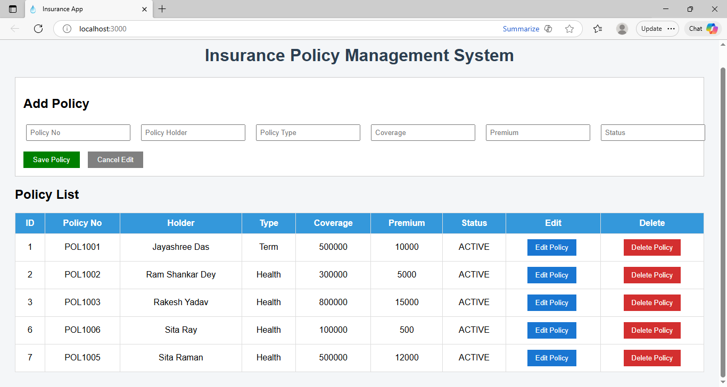

Screen 2 : Add Policy

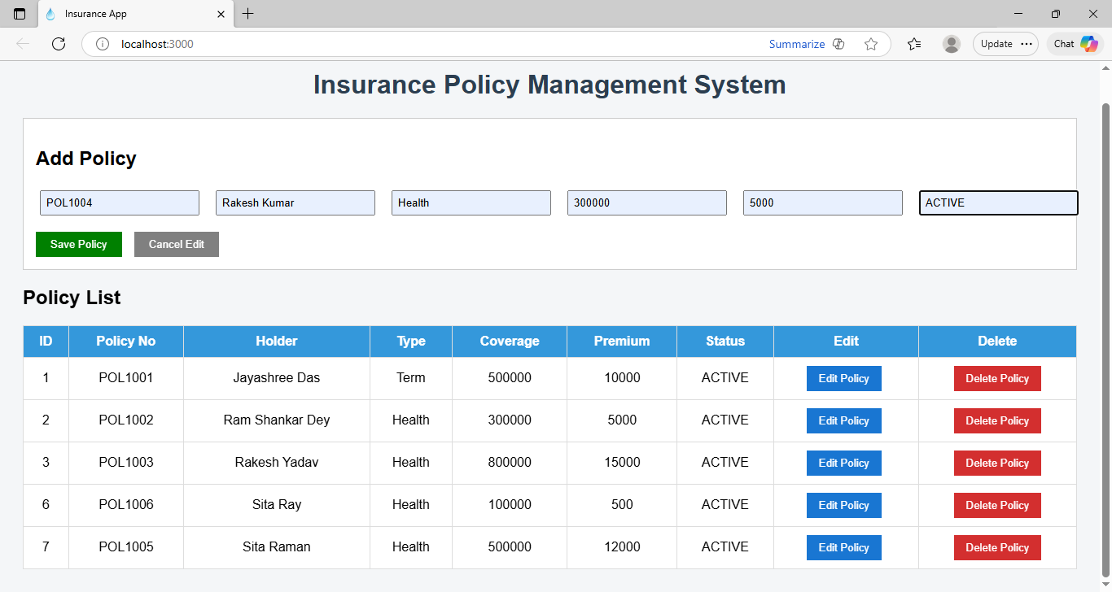

Screen 3 : Edit Policy for POL1001
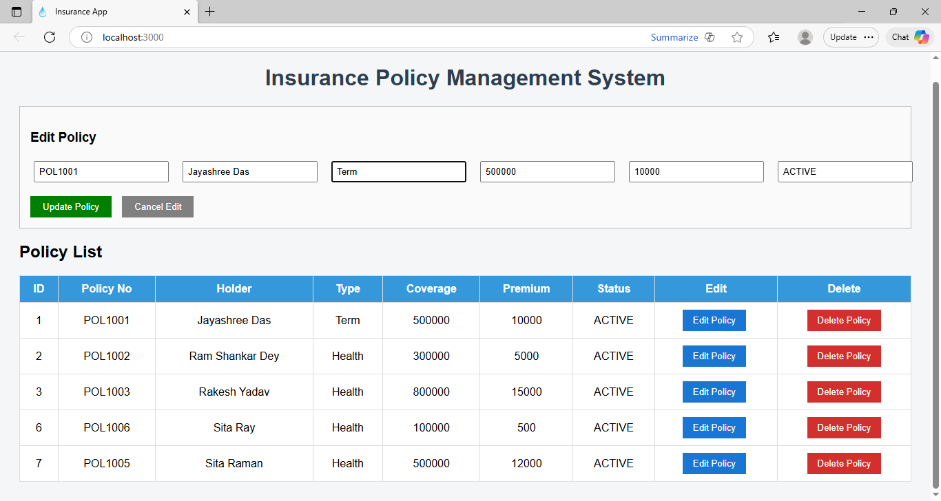
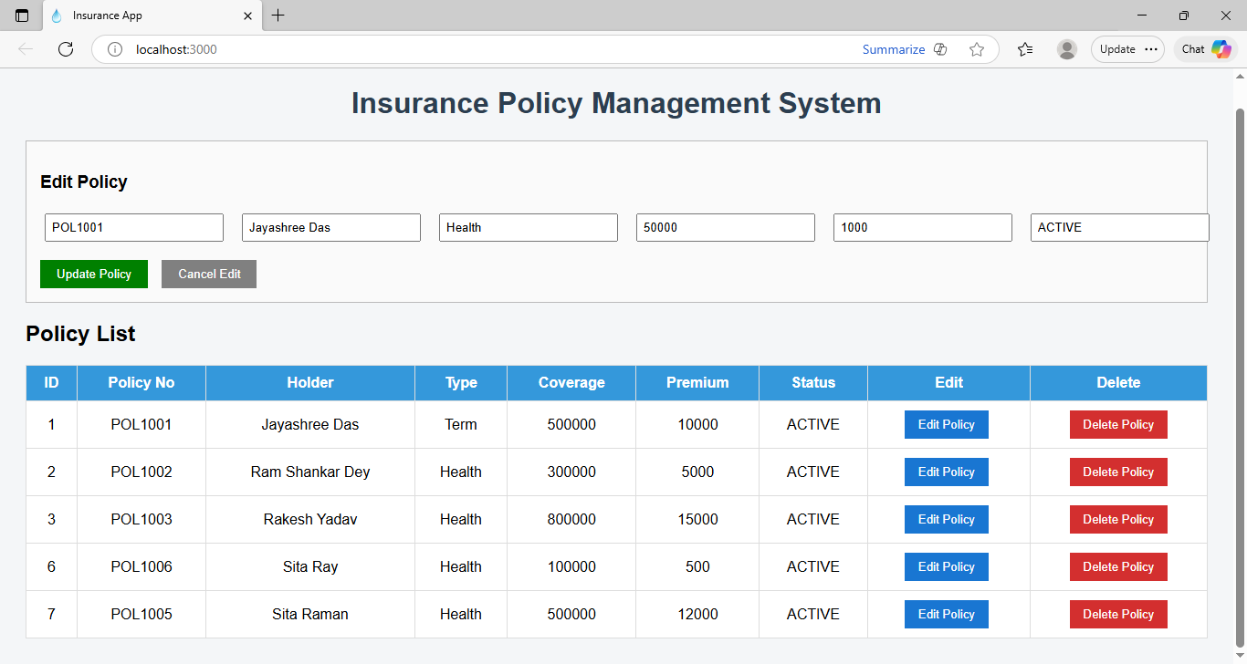
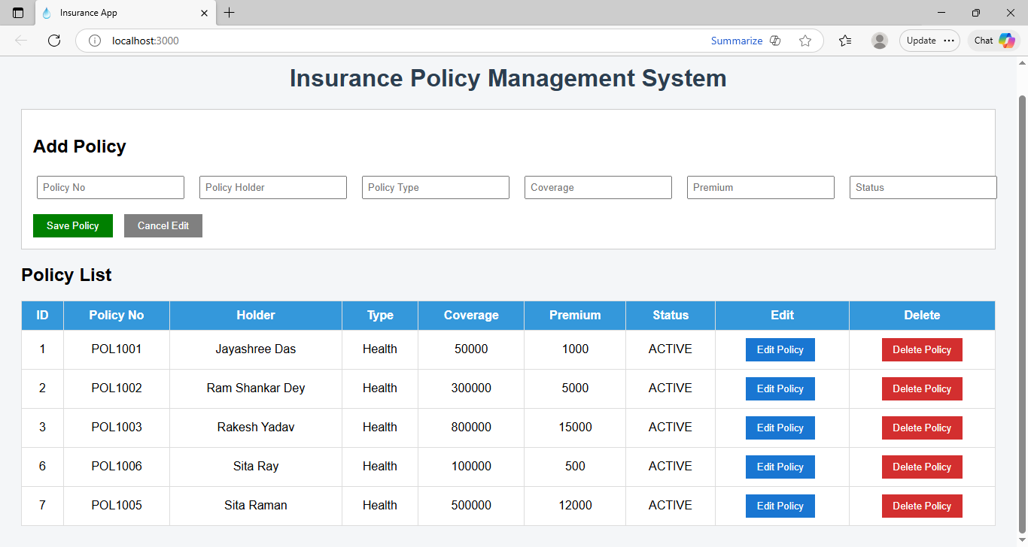

Screen 4 : Delete Policy POL1005
